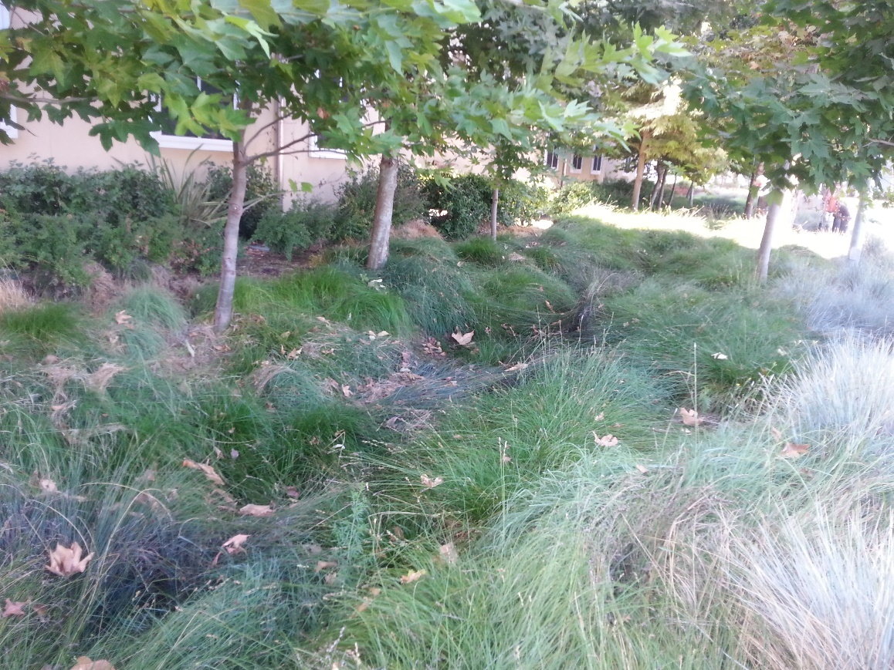
Post-Construction Maintenance Assurance Plan
City of Lathrop
390 Towne Centre Drive City of
Tel (209) 941-7430
http://www.ci.lathrop.ca.us/

[Left intentionally blank.]

Table of Contents
Introduction: 1
Section 1: Definition of Existing Structural Post-Construction BMPs 2
Section 2: The Scope of the Inventory of Existing Structural BMPs 2
Section 3: Inventory Logistics 3
Section 4: Identifying “Authorized Parties” 4
Section 5: Requesting Annual Self-Certification Reports 4
Section 6: Identifying Pollutants of Concern and Receiving Waters 6
Section 7: Assessment of Self-Certification Reports and Prioritizing Maintenance Activities 8
Section 8: Enforcement 9

Collaborating Phase II MS4s:
City of Chico
City of Escalon
City of Lathrop
City of Livingston
City of Lodi
City of Merced
City of Redding
City of Turlock
© Copyright by WGR Southwest, Inc., 2016. This document and its attachments may only be used by permission. Permission is granted by WGR Southwest, Inc. to the collaborating municipalities listed-above in this document.

Post-Construction Maintenance Assurance Plan

Introduction:
The Phase II MS4 Permit requires in Section E.12.i that the City of Lathrop develop and implement a plan to inventory, map, and determine the relative maintenance condition of structural post-construction BMPs. This includes structural post-construction devices that are either privately-owned or municipal-owned. The Permit states that maintenance conditions are to be determined through a self-certification program where the City of Lathrop requires annual reports from authorized parties demonstrating proper maintenance and operations. The Permit requires that the plan include the following elements:
- An inventory and map of existing structural post-construction BMPs (in GIS, if available);
- Assessment of the self-certification program annual reports. The assessment needs to include a ranking of structural BMPs and verification that BMPs are operating to remove pollutants as designed. Regional BMPs should receive higher priority than lot-scale BMPs, and BMPs designed to remove pollutants, for which the receiving water is impaired, should receive priority attention over other BMPs;
- Appropriate escalating enforcement based on the City of Lathrop’s Enforcement Response Plan to ensure proper maintenance of BMPs and the submittal of the annual self-certification reports; and
- A mechanism to require the submittal of self-certification annual reports.
In order to implement the above four elements of the Post-Construction Maintenance Assurance Plan, it is necessary to define the following program elements:
- What are structural BMPs?
- What is considered to be within the scope of the inventory of existing structural BMPs?
- What “authorized parties” need to submit annual self-certification reports?
- How will the owners of structural BMPs be notified of the requirement to submit an annual self-certification report?
- What pollutants of concern are addressed by structural BMPs?
- What are the high priority pollutants of concern for which the receiving water(s) is impaired?
- What is the priority-based ranking system for performing enforcement, inspections, and maintenance and spending maintenance funds on municipal-owned BMPs?
The above program elements are addressed in this Post-Construction Maintenance Assurance Plan. Periodically, the plan should be reviewed to make adjustments to the pollutants of concern and priority-based ranking system as the City of Lathrop’s storm water program matures and changes over time.

Section 1: Definition of Existing Structural Post-Construction BMPs
Structural BMP:
Something that was built to infiltrate, bioretain, evapo-transpire, or capture and reuse storm water.
It includes retention and detention basins; rain gardens; bioswales; roadside or vegetated swales; tree wells to which storm water runoff is directed; infiltration trenches; raised planters designed to infiltrate storm water; dry wells and rock wells; permeable pavement, concrete, or pavers; green roofs; and storm water cisterns or other capture / re-use systems.
On February 17, 2016, during an interview with Bill Hereth of the State Water Resources Control Board, he was asked to define Structural Post-Construction Best Management Practices (Structural BMPs). Bill responded by first defining “structural”, which, according to him, is “something that was built”. In the context of post-construction BMPs, it includes retention basins, bioswales, permeable pavement, and other things built to infiltrate or treat storm water. It does not include low impact development (LID) measures that exist and were protected or utilized (but not built) to infiltrate or treat storm water. An example of this would be trees or a vegetative buffer, which would not need to be included in the inventory. Bill then addressed the word “existing”. He said that the intent of the permit was to include structural treatment controls installed in response to requirements in the current and previous Phase II MS4 permits. He acknowledged that there is no date given in the Permit and that “existing” could potentially include retention basins installed many years ago.

Section 2: The Scope of the Inventory of Existing Structural BMPs
During the February 17, 2016 interview with Bill Hereth, he was asked about the Permit’s requirement to include BMPs used for flood control such as on-site retention basins or other infiltration measures used to handle storm water runoff. For private properties, Bill stated that it really boils down in his thinking to whether an on-site private retention basin is being used by the City of Lathrop to meet its flood control calculations. If it is being used as a credit towards meeting the municipal flood control capacity, then, “yes, it should be included in the inventory required by E.12.i”. However, if it is not being taken as a credit by the City of Lathrop, and if it pre-dates the 2003 issuance of the original Phase II MS4 Permit, it was, therefore, not installed as a post-construction structural control device and does not need to be included in the E.12.i inventory. In regards to municipal-owned and operated infiltration devices, Bill responded by saying that all municipal retention basins need to be included in the inventory regardless of age. When asked about what constitutes an applicable municipal-owned existing structural BMP, Bill responded by stating that not only retention basins should be included in the inventory but anything that has been constructed and is currently owned or operated by the City of Lathrop to infiltrate water should be included in the inventory. This includes some roadside swales.
What the Inventory Needs to Include:
Private property: Any Structural BMPs installed after 2003 (unless it being used as a credit towards meeting the municipal flood control capacity).
Municipal property: Any existing Structural BMP used for flood control regardless of when it was installed. This includes retention and detention basins, dry wells, rock wells, and constructed roadside swales. It also includes any Structural BMPs installed to meet the post-construction requirements under the previous or current MS4 permit.

Section 3: Inventory Logistics
The first logistical question is how to build the inventory. There are two main elements to the inventory: Structural BMPs located on private property; and Structural BMPs on municipal property. In order to identify the Structural BMPs on private property, a search of all development and redevelopment projects dating back to 2003 will need to be performed. Depending upon the record keeping system, this exercise can be either relatively simple or, in other cases, require a time consuming review of individual projects. The review process should attempt to identify projects that were subject to the post-construction standards plan in place at the time. When those projects are identified, each project will need to be reviewed to obtain the following information:
Required Inventory Information:
Project Owner – including name, address, and contact information (this is to whom the annual self-certification report request will be sent)
Project Name / Type – the name of the project and/or what kind of project (subdivision, commercial, industrial, roadway, etc.)
Project Location – Address, latitude and longitude (for mapping on GIS)
Structural BMPs – identify each structural BMP that was installed as part of the project
Receiving Water – this will need to be identified in order to prioritize maintenance activities

In order to identify the Structural BMPs owned and operated by the City of Lathrop, it will be useful to reference municipal roadway and drainage maps; knowledge from the Public Works or Roads Division crews; and aerial photographs (such as Google Earth). Retention basins, dry wells, and rock wells should be fairly straight forward to identify. Roadside swales, however, will present more of a challenge. Bill Hereth of the Water Board, stated that a municipality can take more of a “macro” approach to inventorying roadside swales. First, remember that the roadside swales applicable to the inventory requirement were constructed to primarily infiltrate water. A swale that is used primarily for conveyance to move water from one point to another, would not meet this requirement. However, a swale constructed to retain and infiltrate water at the same place, will need to be on the inventory. Bill Hereth stated that a municipality could include these infiltration swales on the inventory as a complete unit along a particular roadway. For example, “all roadside swales along Hwy. 88 from Pine Street to Riverside Avenue” could be one single inventory entry.
Once the inventory has been completed, the permit requires it to be mapped; preferably on a Geographical Information System (GIS) if the City of Lathrop has one. If a municipality does not have GIS, one relatively easy way to meet this requirement is to use Google Earth to identify all of the locations of the Structural BMPs. Information about the owner and the types of Structural BMPs can also be imbedded into the Google Earth file. It will not be viewable by the public, but only to whom you supply the kml file created by Google Earth.

The City of Lathrop’s Inventory:
The inventory is maintained in the following location: 390 Towne Centre Drive Lathrop, CA 95330
A map of the Structural BMPs can be accessed by: Contacting Greg Gibson Senior Civil Engineer in Public Works Department at City Hall

Section 4: Identifying “Authorized Parties”
In short, the “Authorized Parties” are the property owners. For municipal-owned Structural BMPs, this is obviously going to be the City of Lathrop’s Department of Public Works. However, for private projects, although it will generally be the property owner, there will be some occasions where it is a different entity. Home owner associations or maintenance districts may be considered “authorized parties” especially for situations in which the previously installed Structural BMP serves more than one property. Other “authorized parties” may include property management organizations, corporations, trusts, charitable organizations, or family members who represent the property owner. A good way to identify the “authorized parties” is to review the Operation & Maintenance Plan that was required to be submitted to the City of Lathrop along with the Post-Construction Standards Plan submittal at the time of the project approval. These authorized parties will need to be included in the inventory for each property having Structural BMPs.

Section 5: Requesting Annual Self-Certification Reports
The Permit requires that, beginning in Year 3 (by June 30, 2016), the City of Lathrop will need to request authorized parties to submit an annual self-certification report. The report will include verification that field observations were performed to determine the effectiveness of the structural post-construction BMPs and that a long-term plan for conducting maintenance of the Structural BMPs is being conducted. It will also need to identify the frequency of the planned maintenance. There are a variety of ways this can be accomplished, but we recommend the following approach.
Use the mail merge feature of MS Word to populate a pre-formatted postcard or letter that will be sent to all of the authorized parties on the City of Lathrop’s inventory. A postcard format is shown in Figure 1. Included as an attachment to this Plan is a letter format of the same annual self-certification request.
For the first round, we recommend that these postcards or letters be sent out by June 1, 2016 and a return date be required by June 30, 2016. The postcards or letters will probably not be able to be sent out before June 1, because much of the month of May 2016 will most likely be spent creating the inventory. In future years, it may be advisable to allow a longer period of time for authorized parties to return the postcards.
The City of Lathrop may also want to consider an alternative submittal option consisting of a website for authorized parties to electronically submit their self-certification reports. As a part of this Plan, we have created an example online form and SQL database that the City of Lathrop can adapt, modify, and use for this purpose. A link to the example form is provided as an attachment to this Plan.

City of Lathrop
390 Towne Centre Drive
Lathrop, CA 95330

Authorized Party Name
Address
Lathrop, CA 95330
Figure 1
Example Self-Certification Postcard
For more information, contact Greg Gibson (209) 941-7440 pwk@ci.lathrop.ca.us
.
Important!
Avoid Penalties Respond by
June 30, 2018
A new State Water Board requirement became effective this year which requires the City of Lathrop to contact property owners or other authorized parties to inquire about any design features installed on your property since 2003 that either infiltrate, bioretain, evapo-transpire, or capture and re-use storm water. Examples of these features would include retention or detention basins, rain gardens, bioswales, permeable pavement, green roofs, infiltration trenches, planter or tree well infiltration devices, dry wells, or rock wells. The City of Lathrop has identified the following property has having one or more of these features.

[Name of Project] at [Address of Property]
[Type of Structural BMP]

To comply with this requirement and to avoid penalties, please answer the following questions and either return the signed card in the mail or hand-deliver it to City Hall, 390 Towne Centre Dr.

- Based on field observations, are the featured identified above effective in managing storm water and removing pollutants from storm water runoff? (Yes or No) circle one
- Is there a long-term plan for conducting regular maintenance on the above-listed storm water management features? (Yes or No) circle one
- How often is maintenance performed? _________________
Name of Submitter: ________________ Date: ____________
Signature: ________________________ Email address: ___________________________

Section 6: Identifying Pollutants of Concern and Receiving Waters
In order to be able to prioritize maintenance activities especially for municipal-owned Structural BMPs, it is necessary to evaluate the City of Lathrop’s pollutants of concern and receiving waters as identified in the Program Effectiveness Assessment and Improvement Plan (PEAIP). The following tables have been copied from the City of Lathrop’s PEAIP. Tables 2 and 3 identify receiving water(s) with its respective pollutants of concern based on TMDLs or listing as an impairment on the State Water Board’s 303(d) list.
Table 1. Water Bodies that Have Approved TMDLs
TMDL Pollutants of Condition | Water Bodies Affected
Diazinon & Chlorpyrifos (Pesticides) | Sacramento – San Joaquin Delta Waterways
Organic Enrichment and Low Dissolved Oxygen  (Nutrients, organic material, sugars, oxidizers, etc.) | Lower San Joaquin River
Methylmercury | Sacramento – San Joaquin Delta Waterways
Note:
1. Source: Phase II Permit, Attachment G – Region-Specific Requirements

Table 2. 303(d)-Listed Water Bodies
Watershed | Constituents and/or Conditions
Lower San Joaquin River and Tributaries | Mercury, Pesticides, Exotic Species
Sacramento – San Joaquin Delta Waterways | Mercury, Pesticides, Electrical Conductivity, Exotic Species, Pathogens, PCBs, Dioxin, Furan Compounds
Note:
1. 2010 303(d) List

Table 3. High Priority POCs
Pollutants of Concern | Reason for Listing as a High Priority POC
 | TMDL | 303(d) | Common pollutants
Sediment
Trash
Pathogens
Mercury / Methylmercury
Organic Enrichment / Nutrients
Diazinon & Chlorpyrifos / Pesticides
Note:
1. This table is current as of June 2015. It is dynamic and subject to change as new information is received.

According to the California Stormwater Quality Association (CASQA), Structural BMPs that use infiltration are considered to be medium to highly effective in addressing sediment, nutrients, trash, metals, bacteria (pathogens), oil and grease, and organics.

Section 7: Assessment of Self-Certification Reports and Prioritizing Maintenance Activities
Bill Hereth with the State Water Board has said that the inventory of Structural BMPs should be a tool that municipalities use to determine where best to spend its time, energy, and maintenance funds in protecting water quality. Therefore, the Permit allows for the ranking of Structural BMPs. According to the Permit, Regional BMPs have a higher ranking than lot-scale BMPs. BMPs designed to remove the priority pollutants, as identified in Section 6 of this Plan, are to receive more priority attention over other BMPs. The ranking will affect how the City of Lathrop carries out its enforcement of privately-owned Structural BMPs, and the inspection and maintenance of municipal-owned BMPs.
But, first an assessment must be made of the Self-Certification Reports. To perform the assessment, the following questions are asked based on the submitted (or not submitted) reports.
For Private Properties:
- Who did not return the postcard? The City of Lathrop will need to follow up with the non-filers and follow the enforcement procedures described in Section 8 of this Plan and in the Enforcement Response Plan.
- Which filers stated that their Structural BMPs are no longer effective? The City of Lathrop will need to follow up with these properties to require them to either repair, maintain, or replace the Structural BMP.
- Which filers do not perform maintenance on a regular basis? The City of Lathrop will need to follow up with these properties to require them to perform maintenance that is appropriate for their Structural BMP(s).
For Municipal-owned Structural BMPs:
- What Structural BMPs on the inventory were not inspected and evaluated? The City of Lathrop will need to follow up and make sure that the annual self-certification report is prepared for all of their Structural BMPs.
- Which Structural BMPs need maintenance? The City of Lathrop will need to schedule field work to either repair, maintain, or replace the Structural BMP.
- Of those needing maintenance, which Structural BMPs show field evidence of contributing pollutants identified on Table 4 in Section 6 of this Plan? These BMPs will have the highest priority for maintenance activities.
In order to rank enforcement, inspection, and maintenance activities, the City of Lathrop will take the answers from the above questions and sort them with the following ranking criteria.
Ranking Criteria (highest priority = 1; lowest = 5):
- Direct discharge to a receiving water identified on Table 2 or 3.
- Indirect discharge to a receiving water identified on Table 2 or 3.
- Has frequent discharges to the City of Lathrop’s MS4 system.
- Has infrequent discharges to the City of Lathrop’s MS4 system.
- Typically, does not discharge to the MS4 or the receiving water.

Those ranked at a 1, 2 or 3 should be the first to be enforced, inspected, or receive maintenance. As time and budget allows, BMP locations with rankings 4 and 5 will be addressed after giving attention first to the higher priority items.

Section 8: Enforcement
Structural BMP Maintenance Enforcement Steps:
For late reports:
- Send out second notice 30 days after the initial deadline. Provide a new deadline and state that, if the self-certification report is not submitted by the deadline, a fine of $250.
- If the report is not submitted, issue the fine and require the report to be submitted within 2 weeks.
- If the report is still not submitted, refer the property owner to the Regional Water Quality Control Board for further enforcement.
For removed or ineffective BMPs:
- Notify the owner of their obligation to restore or replace the Structural BMP to an effective state within 30 days. State that a fine will be issued in the amount of $1,000 if the BMP is not restored or replaced by the deadline.
- If the deadline is not met, issue the fine and set a new deadline.
- If the second deadline is not met, refer the property owner to the Regional Water Quality Control Board for further enforcement.

The Enforcement Response Plan (ERP), which is required to be developed by the City of Lathrop during Year 3, must address the proper maintenance of Structural BMPs and the submittal of the required annual self-certification reports. Owners or authorized parties who do not file reports will need to be followed-up on by the municipality as specified in the ERP. The Water Board expects a monetary penalty to be issued by the City of Lathrop to those who do not submit annual self-certification reports. The City of Lathrop would be compliant as long as they have an adequate ERP and are implementing it. The Water Board has said that the municipality is not responsible to perform an inspection of those private properties for which the owner did not submit a report; because the report is supposed to be a “self-certification”. Ultimately, non-filers will need to be reported to the Water Board as a part of the progressive enforcement program.
Other forms of non-compliance that required action through the City of Lathrop’s ERP include maintenance of Structural BMPs that is not being performed; Structural BMPs that need to be repaired, maintained, or replaced; and Structural BMPs that have been removed and not replaced. The City of Lathrop’s municipal code was required to be revised during Year 2 to provide it with the necessary legal authority to require compliance with the maintenance and upkeep of the existing Structural BMPs.

[Left intentionally blank.]

Attachment A – Annual Self-Certification Request Template Letter

[Left intentionally blank.]

Attachment B – Link to Example Online Response Form

[Left intentionally blank.]

January 2003 CASQA BMP Fact Sheets TC-11 for Infiltration Basins: https://www.casqa.org/sites/default/files/BMPHandbooks/TC-11.pdf; and TC-32 for Bioretention https://www.casqa.org/sites/default/files/BMPHandbooks/tc-32_from_newdevelopmentredevelopment_handbook.pdf

